Session-5 Database
- Create two tables in SQL: influencers (with influencer_id as PRIMARY KEY and name) and posts (with post_id as PRIMARY KEY, influencer_id as FOREIGN KEY, and caption). Insert at least 3 influencers and 2 posts for each influencer.
Ans.
-- Create influencers table CREATE TABLE
influencers (
influencer_id INT PRIMARY KEY,
name VARCHAR(100)
);
-- Insert 3 influencers
INSERT INTO influencers (influencer_id, name)
VALUES
(1, 'Aarav Sharma'),
(2, 'Priya Patel'),
(3, 'Rohan Mehta');
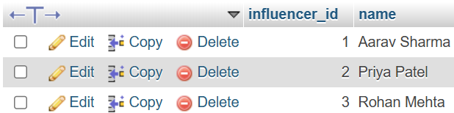

-- Create posts table
CREATE TABLE posts (
post_id INT PRIMARY KEY,
influencer_id INT,
caption VARCHAR(255),
FOREIGN KEY (influencer_id) REFERENCES influencers(influencer_id)
);
-- Insert 2 posts for each influencer
INSERT INTO posts (post_id, influencer_id, caption)
VALUES
(101, 1, 'Morning workout complete!'),
(102, 1, 'Healthy breakfast ideas.'),
(103, 2, 'Traveling to Goa today.'),
(104, 2, 'Sunset at the beach.'),
(105, 3, 'Learning SQL is fun!'),
(106, 3, 'New coding project started.');
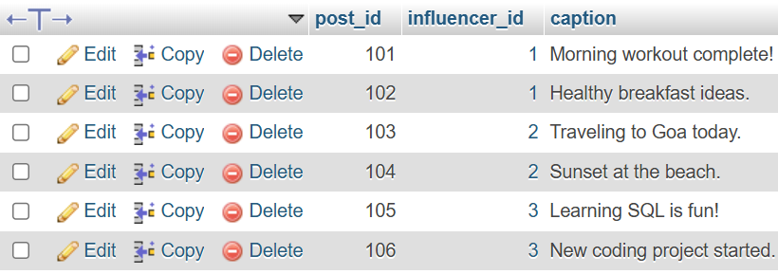

- Write an SQL query using INNER JOIN to display each post's caption along with the name of the influencer who posted it, based on the tables you created.
Ans.
SELECT influencers.name, posts.caption
FROM influencers
INNER JOIN posts
ON influencers.influencer_id = posts.influencer_id;
Output
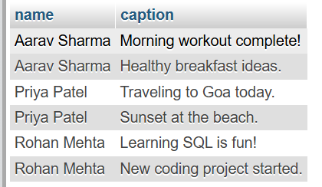

- Write an SQL query using LEFT JOIN to show all influencers and their posts, including influencers who haven't posted anything yet. If an influencer has no posts, display 'No Posts' in the caption column.<br><br><em><strong>Hint:</strong> Use IFNULL or COALESCE to handle NULL values in the result.</em>
Ans.
SELECT
influencers.name,
IFNULL(posts.caption, 'No Posts') AS caption
FROM influencers
LEFT JOIN posts
ON influencers.influencer_id = posts.influencer_id;
Output
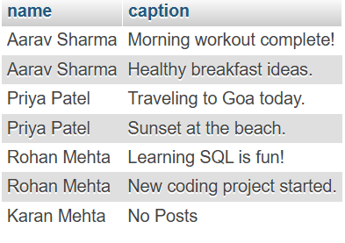

- Write an SQL query using RIGHT JOIN to list all posts and the corresponding influencer's name, ensuring that even posts without a matching influencer_id (if any) are shown.
Ans.
SELECT
posts.caption,
influencers.name
FROM influencers
RIGHT JOIN posts
ON influencers.influencer_id = posts.influencer_id;
Output
